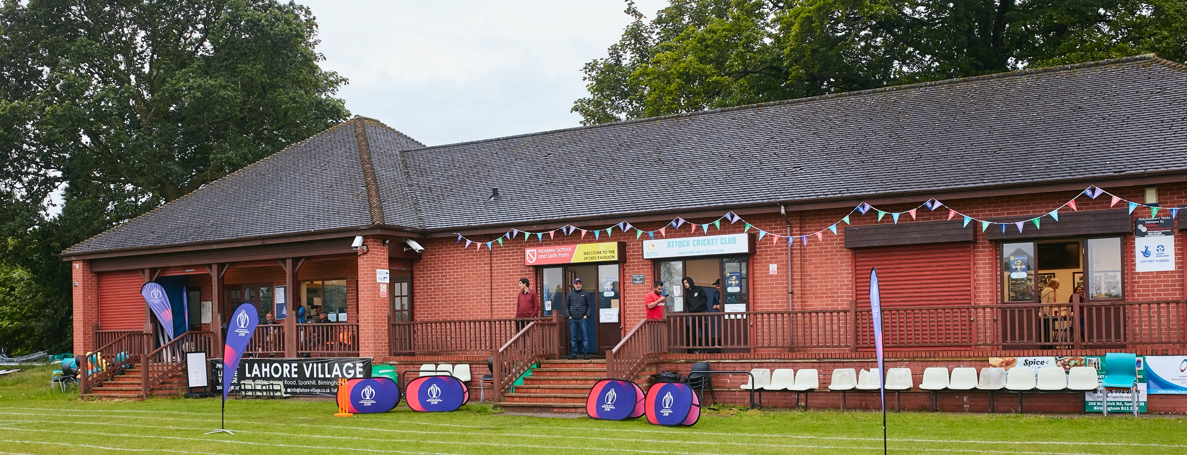

RISK ASSESSMENT TEMPLATE FOR CLUBS PREPARING TO OPEN THEIR CLUBHOUSE

Risk Assessment Template
As a facility provider, you should complete your own COVID-19 Risk Assessment and publish this to your users.

If you are not the facility provider, then you should consider which sections will apply to your clubs individual situation upon returning to play and complete a risk assessment based on your activity, including (but not limited to) people management and communication, hygiene and first aid. You may still wish to record that you have assessed facility risks through enquiries made with your facility provider.

We have provided an example risk assessment below, which is for illustrative purposes only, and includes some examples of things to consider. Consider how this will apply to each aspect of your operation and identify the controls you require to meet Government guidance regarding health, social distancing and hygiene etc. Remember that you must review your other Health and Safety, and Safeguarding, risk assessments for other hazards such as fire, first aid etc.
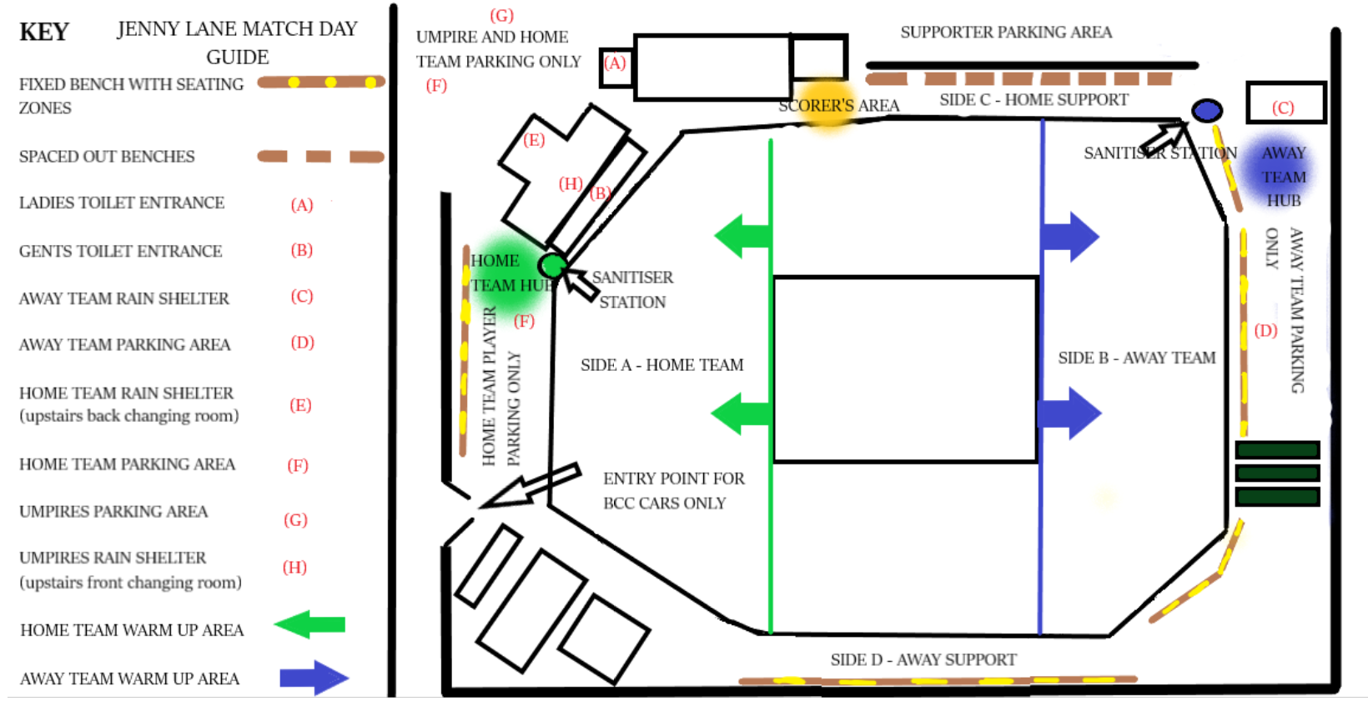

What are the hazards? |  | Transmission of COVID-19
Who might be harmed? |  | Facility users, staff, volunteers, visitors and the wider community
No | Controls required |  |  | Action Taken by the Club
People Management and Communication
1 | Self-screening of individuals before they arrive at the venue to ensure individuals displaying COVID-19 symptoms or those who should be shielding do not travel or attend. |  | Home Team – on the day before the game, all players, coaches and officials who will be present at the ground on match day are to text the club’s appointed Covid-19 Co-ordinator (Ashley Free) to advise they are fit and healthy and displaying no symptoms and that all other people in their household are in a similar position. The Covid-19 match day supervisor (one member of that day’s playing eleven) will then turn this information into a register and provide to the responsible match day individual to tick off those people in attendance the following day.  Away Team – will be asked to send a list via e-mail to Baildon CC’s Covid-19 Co-Ordinator, which details the same information as listed above. Again this will be used to create a match day register.  The Covid-19 match day supervisor will then take a picture of both registers and e-mail them to the Covid-19 Co-Ordinator who will save them for a period of 21 days.  Supporters of each team will be asked to sit in designated areas and not come within 2m of any players. Their details will also be collected by the respective home team’s Covid-19 match day supervisor and sent to the Covid-19 Co-ordinator as before.  The appointed match day supervisor will make sure all persons in attendance have either been ticked off against the match day register as provided, or have been added on – full name and contact phone number. This will be on a clipboard provided in the green shed which should be wiped down before and after use with a disposable wipe.
2 | An assessment of user numbers, space capacities, venue circulation and layout planning to maintain social distancing. |  |  | Each team will be allocated one side of the ground for social distancing purposes. Home team have the side that is adjacent to the changing rooms building (Side A on the diagram on page 2), their cars are to be parked there or behind the changing rooms. The opposition have the far side of the ground (Side B on the diagram), adjacent to the equipment storage sheds. Their cars are to be parked there or the bottom end of the car park between the rugby and cricket pitch. Umpires will have two allocated spaces behind the changing rooms.  Scorers will operate outdoors, in front of the main window at the bottom end of the bar building.  Gentleman’s toilets are provided on the bottom floor of the changing rooms. One way access is in place as per the diagram on page 5.  Ladies’ toilets are provided in the bar building. One way access is in place as per the diagram on page 5.  All ground users are asked to walk around the pitch in a clock wise direction – to minimise the chance of coming into close contact with each other. Their will be a marked channel around the ground with additional space around the pitch.  All spectators and players are asked to only touch the ball when they are active participants in the match – once the ball crosses the boundary it should only be retrieved by a member of the fielding team. If it is touched by anyone else it should be cleaned with a disposable wipe before the game continues.
3 | A plan for where parents and players will sit whilst watching cricket activities. |  |  | All players and supporters are encouraged to bring their own individual chair and hand sanitiser with them. Visiting supporters are allocated the seating area at Side D of the ground, the Heygate homes end, as per the attached diagram. An area around the sightscreen will be left clear.  Home supporters are allocated the seating area at Side C of the ground, the rugby end, as per the attached diagram. An area around the sightscreen will be left clear.  Home team will sit on side A and the Away team will sit on side B.
4 | Signage and communication so that all participants and visitors are aware of the control measures in place and how to act appropriately to minimise the risk of transmission of COVID-19. |  |  | This risk assessment will be available on our website for all to see. We will also make sure that it is sent to all teams who will visit Jenny Lane this season to ensure they adhere to our ground rules.  Appropriate signage will be displayed around the ground – by the entrances to both toilets and one sign per ground area (i.e Side A - home team, Side B – away team, Side C – home supporters, Side D – away supporters)
5 | Staff and volunteer training to support the implementation of the plan, with suitable training records. |  |  | Ashley Free is the named Covid-19 Co-ordinator for Baildon CC. His contact details are as follows; mobile number 07415 709104, e-mail address ashleyhaydenfree@yahoo.co.uk He will be supported on each match day by an appointed Covid-19 match day co-ordinator (a member of the home playing team), who will be responsible for ensuring that the relevant match day procedures/actions are followed. This person should not be the captain. The match day procedures will be clearly laid out on a laminated sheet and simple enough for all to follow. This sheet should be wiped clean before and after the match and kept with the other sanitizing products in the green shed.
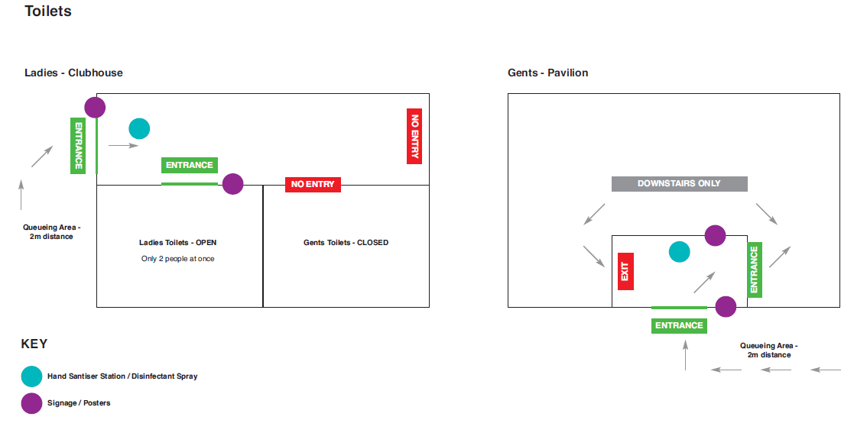
Buildings
6 | Assess ventilation in your building (natural and mechanical) and take appropriate measures to maximise ventilation and minimise risk of transmission. |  |  | Doors and windows in the relevant toilet blocks will be kept open to ensure air flow.
7 | Assess the maximum occupancy of your rooms at 2m social distancing (or 1m with risk mitigation where 2m is not possible) and establish a suitable circulation system/one-way system. Use signage and floor markings to communicate this. |  |  | Access and use of toilets (separate buildings for men and women) are all laid out on social distancing guidelines – see diagram on previous page.  All other buildings are off limits apart from shelter provided in wet weather – see section 9.
8 | Assess the arrangement of seating areas to maintain social distancing and minimise the risk of transmission. |  |  | All benches are spaced out to allow 2m distance between benches. On fixed benches every other bench is marked as not suitable for use to ensure 2m distance between individuals. All seating will be wiped down before and after games. Where possible all people attending the game will be encouraged to bring their own chair.
9 | Consider your wet weather plans and describe what actions you will take to maintain social distancing in wet weather. |  |  | In the first instance, all players, officials, umpires and supporters will be encouraged to return to their vehicles individually accept in instances where social distancing is possible due to the size of the car or people concerned are in an existing family/support bubble.  If this is not possible, umpires will be allowed to shelter in changing room 4 (upstairs front of the changing rooms). Scorers will shelter in the bottom room of the bar area. Home team will shelter in changing room 3 (upstairs back of the changing room). Visiting team will have access to the equipment storage sheds in the blue shaded area of the pitch diagram along with the rugby stand in the main car park. Please note that we are unable to offer Supporters any undercover areas to shelter from the rain. All to be done with consideration to 2m social distancing.  If rain is forecast for the afternoon – or if the covers are already on the wicket, put on disposable gloves, wipe down the areas used to push the covers and move on or off as appropriate. Wipe down pushing areas after the match.  Wearing disposable gloves, get sawdust bucket from green shed and place near boundary edge. Players should wipe down bucket before and after use. If threat of rain is obvious before the start of the match, remove blue super sopper from green shed and wipe down all handle areas to prepare for use. After match wipe down again and put back into green shed. Follow same procedure for any brushes, forks that are used to deal with rain fall.
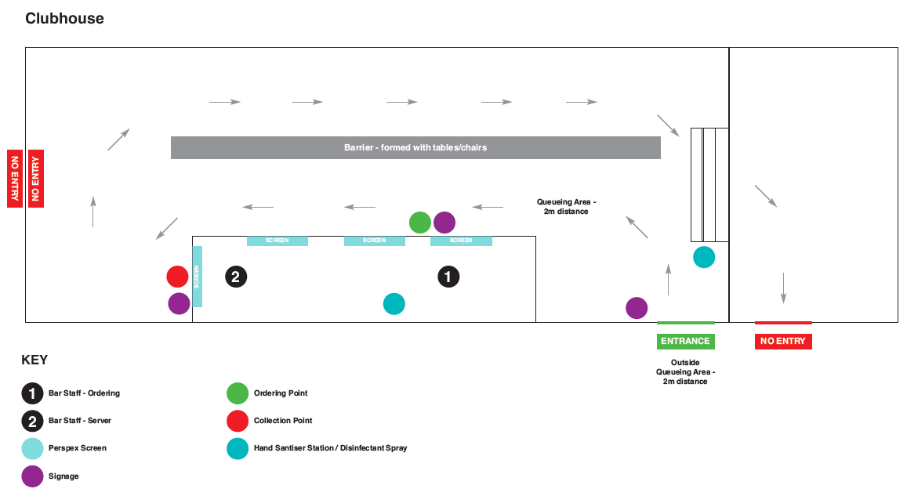
Social and Hospitality Areas

10 | Plan to solicit and maintain records of your member attendance, customers and visitors - to be maintained for 21 days and then destroyed. |  |  | All visitors who purchase anything at the bar will have their details kept on record for a period of 21 days in line with track and trace guidelines.
11 | Identification of suitable areas for outdoor service that don’t overlap with cricket activity. |  |  | Drinks can only be purchased from and taken away from the bar by customers. Staff will not deliver drinks outside of bar. (for more details see separate risk assessment held by joint club)
12 | Steps taken to minimise time and the number of people at the bar. |  |  | Social distance queue system will be in operation along with a split service operation. One member of staff taking the customer’s order and payment with a separate member of staff serving the drinks. Protective screens in place.
13 | Steps taken to minimise contact points at payment or around the hospitality space. |  |  | Social distance queue system will be in operation along with a split service operation. One member of staff taking the customer’s order and payment with a separate member of staff serving the drinks. Protective screens in place.
14 | Suitable PPE provision and training for staff and volunteers. |  |  | All bar staff are provided with a face mask and a clear training plan.
15 | Strategy for the safe serving, clearing and cleaning of glassware and tableware. |  |  | Customer is responsible for their own tray, to carry their own drinks to and from the bar.
16 | Deep cleaning strategy to minimise COVID-19 transmission risk |  |  | All bar cleaning to take place by Joint Club as per regulations.
17 | Daily cleaning strategy to minimise COVID-19 transmission risk. |  |  | All bar cleaning to take place by Joint Club as per regulations.
18 | High-frequency touchpoint cleaning strategy to minimise COVID-19 transmission risk and how you will keep records. |  |  | All bar cleaning to take place by Joint Club as per regulations.
Hygiene and Cleaning
19 | Materials, PPE and training that you have provided to your staff for effective cleaning. |  |  | Bar area maintained under risk assessment covered in note 11. Toilets to be cleaned with disposable wipes before during and after all games, on the day of the game.
20 | Provision of hand washing facilities with warm water, soap, disposable towels and bin. |  |  | These facilities are available in both toilet locations. Supplies of soap, Supplies will be replenished during the day as and when required.
21 | Provision of suitable hand sanitiser in locations around the facility to maintain frequent hand sanitisation. |  |  | Hand sanitizer station at the entrance to both toilets. Hand sanitizer station at both team hub areas.
22 | Provision of suitable wipes and hand sanitiser on the field for hygiene breaks. |  |  | Disposable wipes stored in home team hub area for bats, balls etc. Hand sanitizer stations available for each team. Players encouraged to have their own sanitizer for this purpose.
 | What are the hazards? | Other venue hazards to be considered after temporary closure such as Legionnaire’s Disease, fire, electrical safety etc.
 | Who might be harmed? | Facility users, staff, volunteers and visitors
 | Controls required |  |  | Action Taken by the Club
Preparing Your Buildings
23 | Consider the risk of Legionnaire’s disease and carry out necessary work to make your water supply safe for users. Refer to the specific guidance in the document above. |  |  | Showers not provided for use of any person this season. All taps in toilets have been subject to the appropriate anti-legionnaires running through procedures.
24 | Check that routine maintenance has not been missed and certification is up to date (e.g. Gas safety, Electrical Safety and Portable Appliance Testing, Fire Safety, Lifts and Heating – Ventilation and Air Conditioning). |  |  | All routine maintenance and certification is up to date.
25 | Check that your ground is ready and safe to play. Look at what work is required and how this can be done safely at a social distance. |  |  | Ground works all up to date. Checked weekly by groundsperson.
 | What are the hazards? | Vital first aid equipment is not available when needed. First aiders do not have adequate PPE to carry out first aid when required.
 | Who might be harmed? | First aiders, facility users, staff, volunteers and visitors
 | Controls required |  |  | Action Taken by the Club
First Aid
26 | Check that your first aid kits are stocked and accessible during all activity. |  |  | First aid kit available in home team hub area.
27 | What steps have you taken to improve your first aiders’ understanding of first aid provision under COVID-19? |  |  | Sarah Shaw – safe hands co-ordinator is fully abreast of all updated first aid provisions – circulated around members and on club website.
28 | If you have an AED then check that it is in working order, service is up to date and that it is available during all activity. |  |  | Situated in bar area, maintained by joint club, service up to date.
 | What are the hazards? | Pitches or outfield are unsafe to play on
 | Who might be harmed? | Players, officials, ground staff
 | Controls required |  |  | Action Taken by the Club
Preparing your Grounds
29 | Safety checks on machinery, sightscreens and covers. |  |  | Responsibility of groundsperson Chris Reynolds and checked by Covid-19 co-ordinator Ashley Free. Performed weekly.
30 | Check and repair of any damage to pitches and outfields. |  |  | Responsibility of groundsperson Chris Reynolds and checked by Covid-19 co-ordinator Ashley Free. Performed weekly.
31 | Surfaces checked and watering regime adjusted based on lack of rainfall. |  |  | Responsibility of groundsperson Chris Reynolds and checked by Covid-19 co-ordinator Ashley Free. Performed weekly.
 | What are the hazards? | Use this space to identify hazards at your venue
 | Who might be harmed? | Use this space to identify who might be harmed
 | Controls required |  |  | Action Taken by the Club
32 | Pre match warm up areas. |  |  | See attached pitch diagram, home team have the area marked with green arrows adjacent to their hub. Visiting team have the area marked with blue arrows adjacent to their hub.
33 | Pre match anti-Covid-19 actions. |  |  | Appropriate team member who has been appointed Covid-19 match day supervisor to ensure that the following actions take place;  - Fielding circle disks will already have been put in place by groundsperson, these are not to be touched by any player on match day and will be removed and sanitized by the groundsperson the following day.  - Groundsperson will have already marked the additional running channels on the side of the match wicket.  - Open green storage shed, changing rooms, bar doors, main ground gates. Use disposable wipes to clean each surface you have touched.  - Set out sanitizing stations (stored in changing rooms) at each teams hub and entrance to both toilets. Wipe down all relevant surfaces with disposable wipes.  - Get out wicket marking paint, ruler and brush from green shed ready for half time – wipe all down with disposable wipes.  - Wipe down handles on both hand rollers.  - Wipe down all surfaces on the entrance to and exit from the toilets.  - Wipe down all surfaces including the toilets and sinks, in the men’s and women’s toilets.  - Wipe down scorer’s tables and chairs and scoreboard control device.  - Wipe down separate junior scoreboard which is to be used to display first innings total – this is to be placed in front of the scoring area.  - Put out the match stumps and bails, wipe down all surfaces before finishing.  - Position sightscreens in line with wicket, wipe down surfaces after touching. Ensure appropriate wipes are positioned by each screen for movements during the game.  - Get out clip board and pen from green shed, sanitise with disposable wipe. This should have been pre completed with the name and phone number of all home and away players, umpires, and supporters who have texted the Covid-19 co-ordinator that they will be in attendance that day.
34 | 6 Over sanitizing breaks throughout the game |  |  | All players are encouraged to leave their own waterbottle and hand sanitizer (if inappropriate to keep in their pocket) at intervals around the boundary (where they would also keep their jumper, hat or other items of disgarded clothing). This should respect social distancing guidelines with a gap of at least 2m between each player’s belongings.  Batters should sanitise their bat with the supplied wipes before and after their innings.
35 | Match interval anti-covid-19 actions. |  |  | Repeat pre-game cleaning routine;  - Wipe down all surfaces on the entrance to and exit from the toilets.  - Wipe down all surfaces including the toilets and sinks, in the men’s and women’s toilets.  - Wipe down appropriate areas on sightscreens along with all of the surface of stumps and bails.  - Roll, brush and re-mark each end of the match wicket. When finished wipe down all equipment used (including roller handles) and replace back into green shed.  - Tick off all people in attendance on the provided register. Take down the name and phone number of anyone not appearing on the list.
36 | Post-match anti-covid-19 actions. |  |  | Repeat pre-game cleaning routine;  - Wipe down all surfaces on the entrance to and exit from the toilets.  - Wipe down all surfaces including the toilets and sinks, in the men’s and women’s toilets.  - Wipe down appropriate areas on sightscreens.  - Wipe down and store stumps and bails (kept in green shed)  - Wipe down and store scorer’s tables, chairs, scoreboard scoring device (all kept in bar) and first innings total scoreboard (kept in green shed).  - Lock main gate once all players vehicles have exited. Lock changing rooms, bar door, exterior gate, green shed and equipment store rooms (retain a couple of wipes to clean down all surfaces touched whilst locking up).  - If not already done so, e-mail pictures of matchday register to show all people who have attended the ground along with their contact phone number to Ashley Free, to keep for 21 days before destroying. Clipboard to be wiped down and returned to the green shed with the other sanitizing products.

 | What are the hazards? | Use this space to identify hazards at your venue
 | Who might be harmed? | Use this space to identify who might be harmed
 | Controls required |  | Action Taken by the Club
 | Identify your own control measures required.

